AI_PHASE 5 IBM

TITLE: FAKE NEWS DETECTION USING NLP

Phase 5: Project documentation and submission



TEAM MEMBERS: REG NO

E.ARJUNAN 810621104005

FAKE NEWS DETECTION USING NLP

**Problem Statement:**

Addressing this issue requires leveraging advanced technologies such as Natural Language Processing (NLP) and Artificial Intelligence (AI) to develop accurate and efficient fake news detection systems.

The problem at hand involves creating an innovative AI-based solution that can effectively identify and classify fake news articles from genuine ones, utilizing the power of NLP techniques.

# Phases of development: Phase 1:

We collected and explored a given dataset and explain about the project. Choose the fake news dataset available.

# Phase 2:

we can explore innovative techniques such as ensemble methods and deep learning architectures to improve the prediction system's accuracy and robustness.

Consider exploring advanced techniques like deep learning models (e.g., LSTM, BERT) for improved fake news detection accuracy.

# Phase 3:

Begin building your project by loading and preprocessing the

dataset.

Begin building the fake news detection model by loading and

preprocessing the dataset.

Load the fake news dataset and preprocess the textual data.

# Phase 4:

Continue building the fake news detection model by

applying NLP techniques and training a classification Model. Text Preprocessing and Feature Extraction Model training and evaluation.

**Dataset description:**

# Dataset: [Fake news detection]

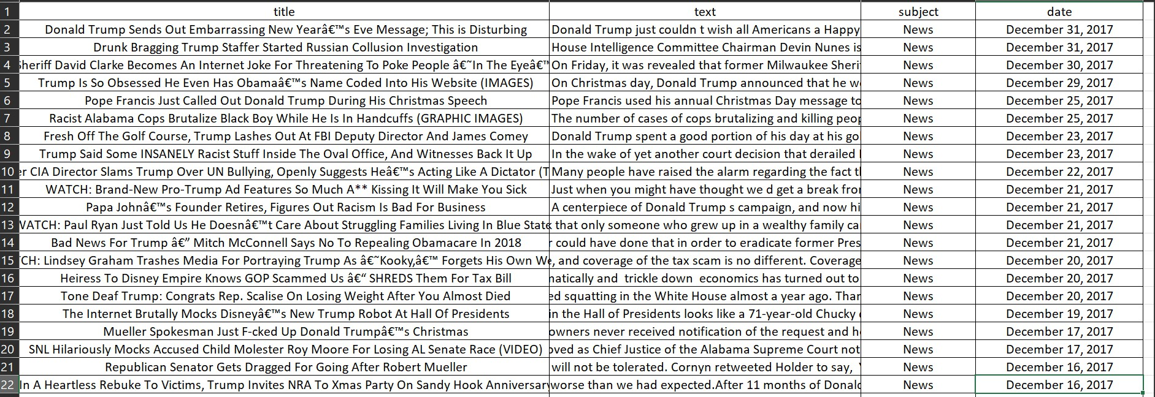

Features: [List key features such as Title, text , subject , date ]

# Data Preprocessing:

There are a number of libraries available that can help with data preprocessing tasks, such as handling missing values, encoding categorical variables, and scaling the features.

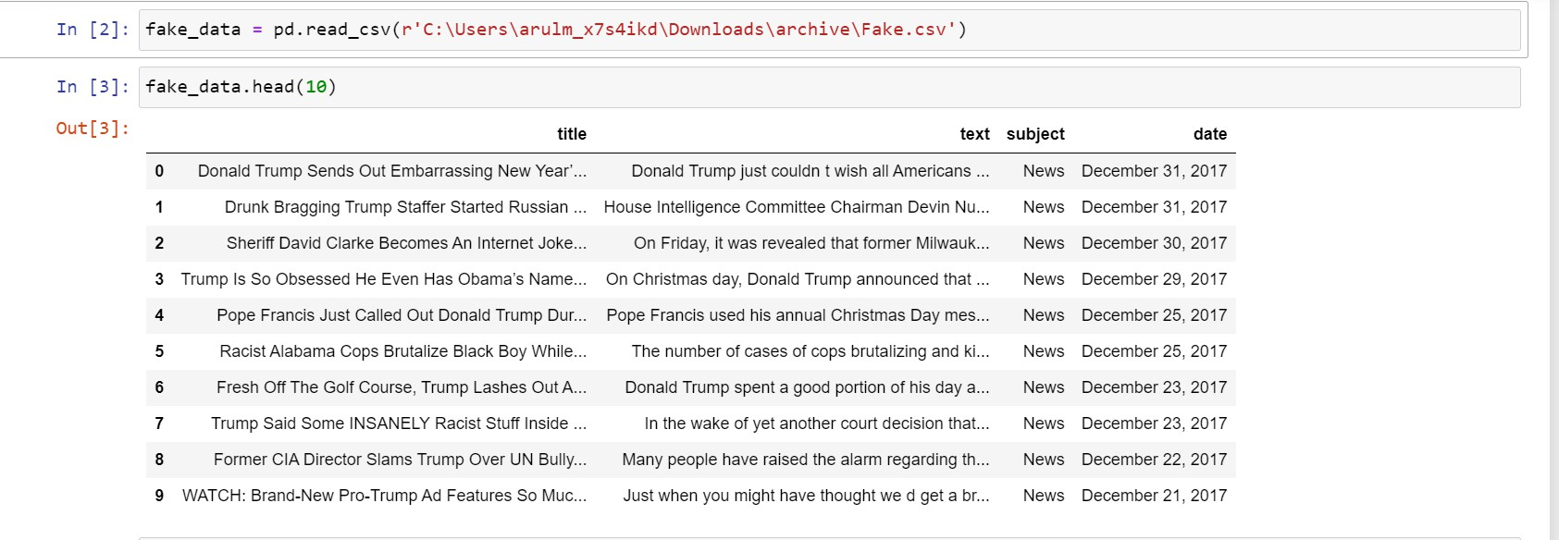

[PREPROCESSING]

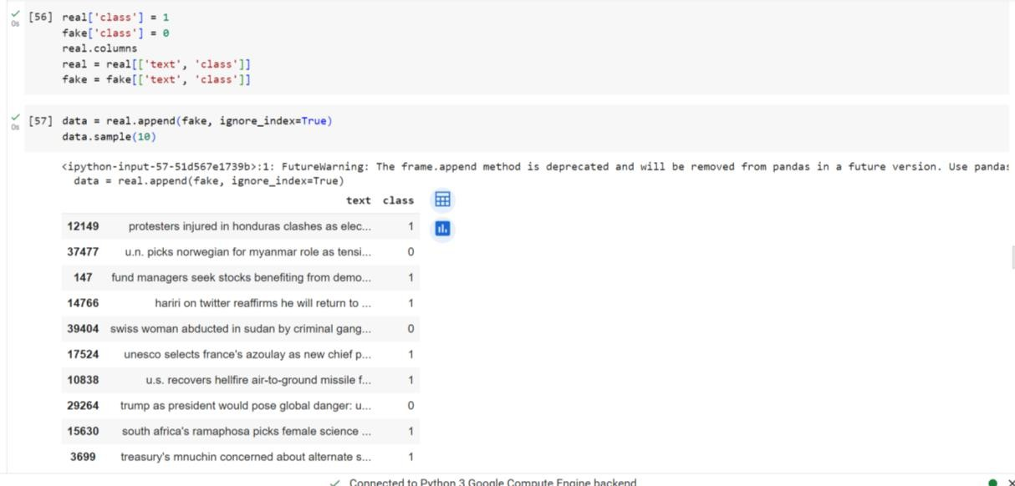

# Outlier Detection and Treatment:

Explain the approach to identifying and addressing outliers.

# Feature Selection

Unknown publishers is the text ,object Feature

Engineering;

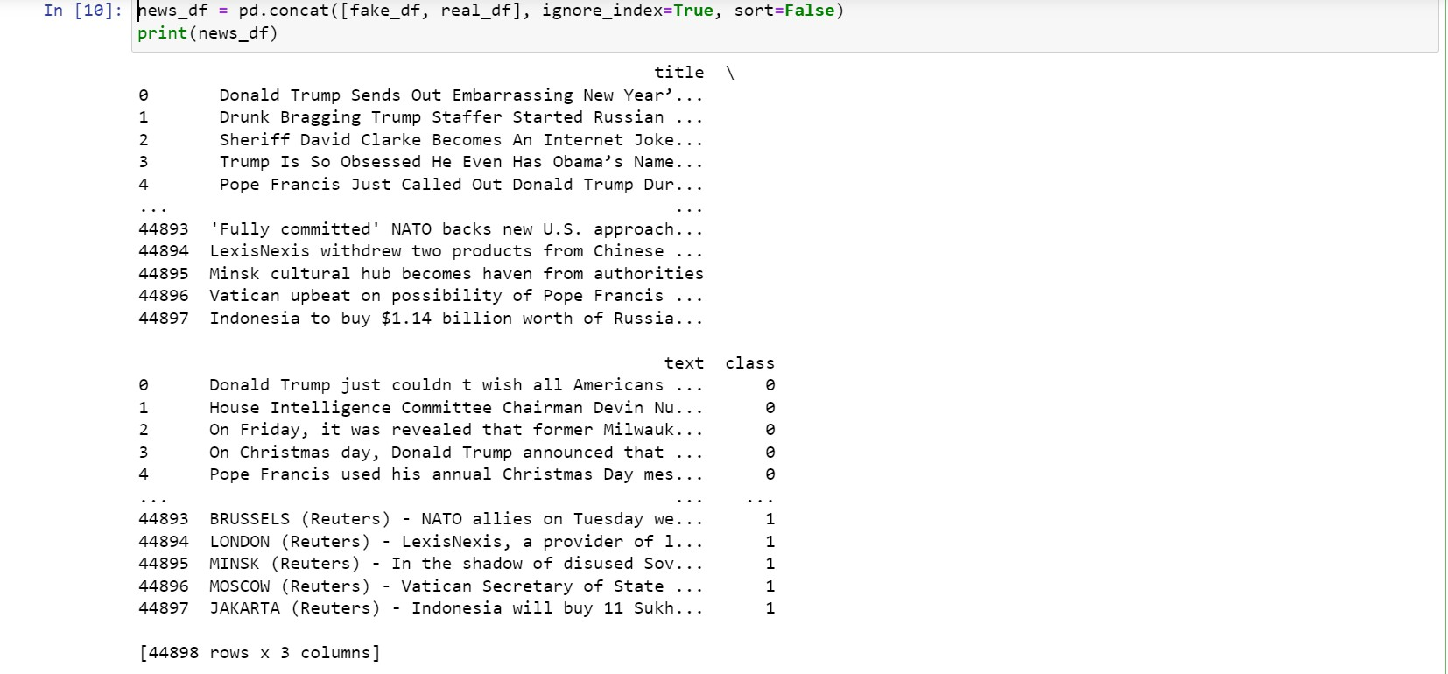

Selecting a future direction for fake news detection using NLP involves considering emerging trends, challenges, and opportunities in the field of natural language processing and misinformation detection.

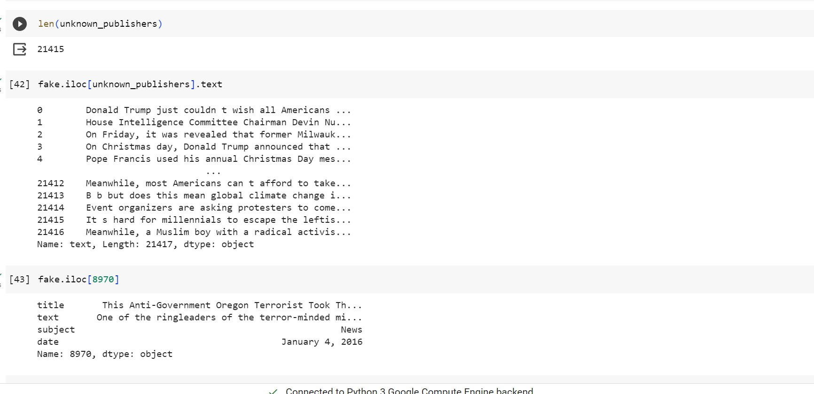

# Machine Learning Algorithm:

Chosen algorithm ; state the

Machine learning algorithms used ( eg.. LSTM)

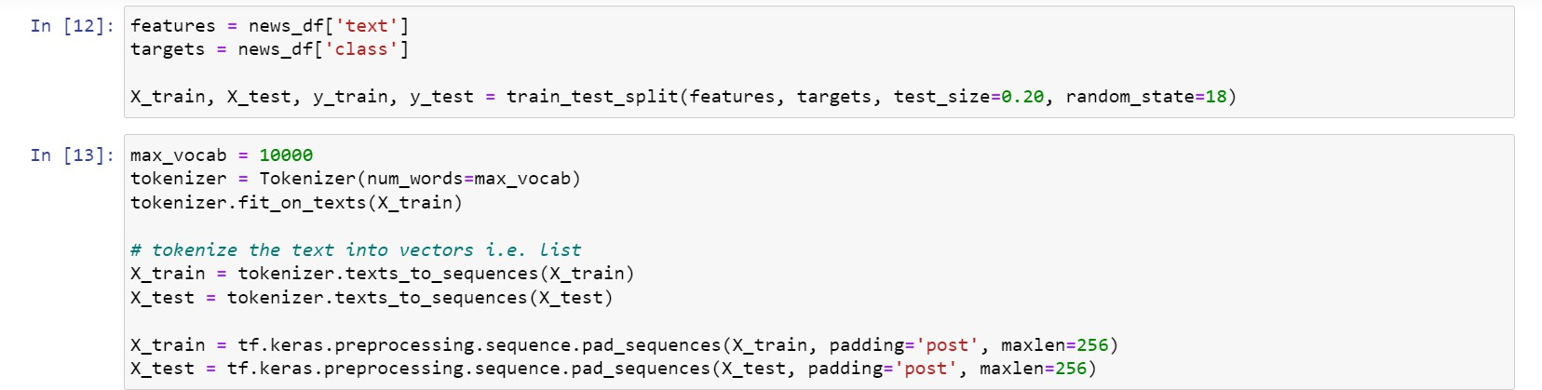

Machine learning algorithms used ( eg.. LSTM)

* First load in the data. The preprocessing only consist of normalization and the creation of windows.
* Creation of the LSTM model
* Training the LSTM model

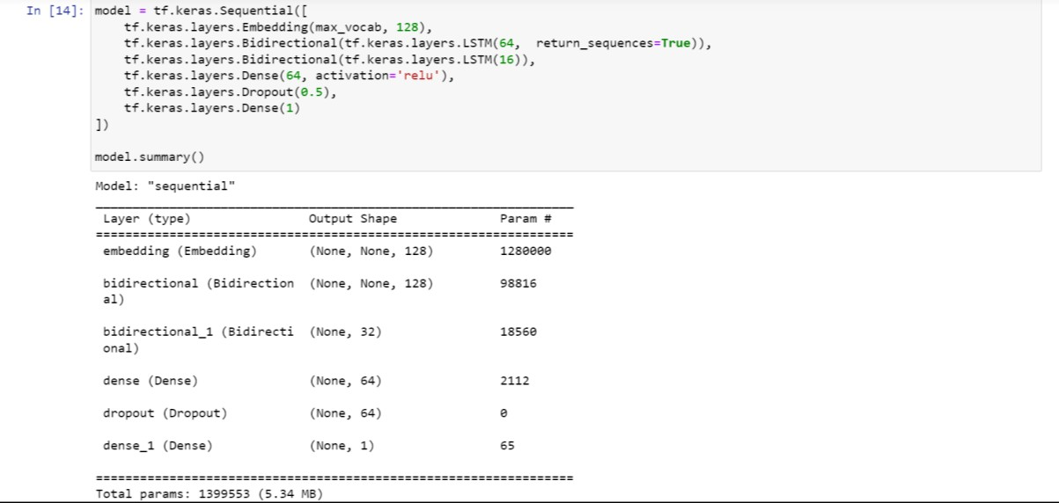

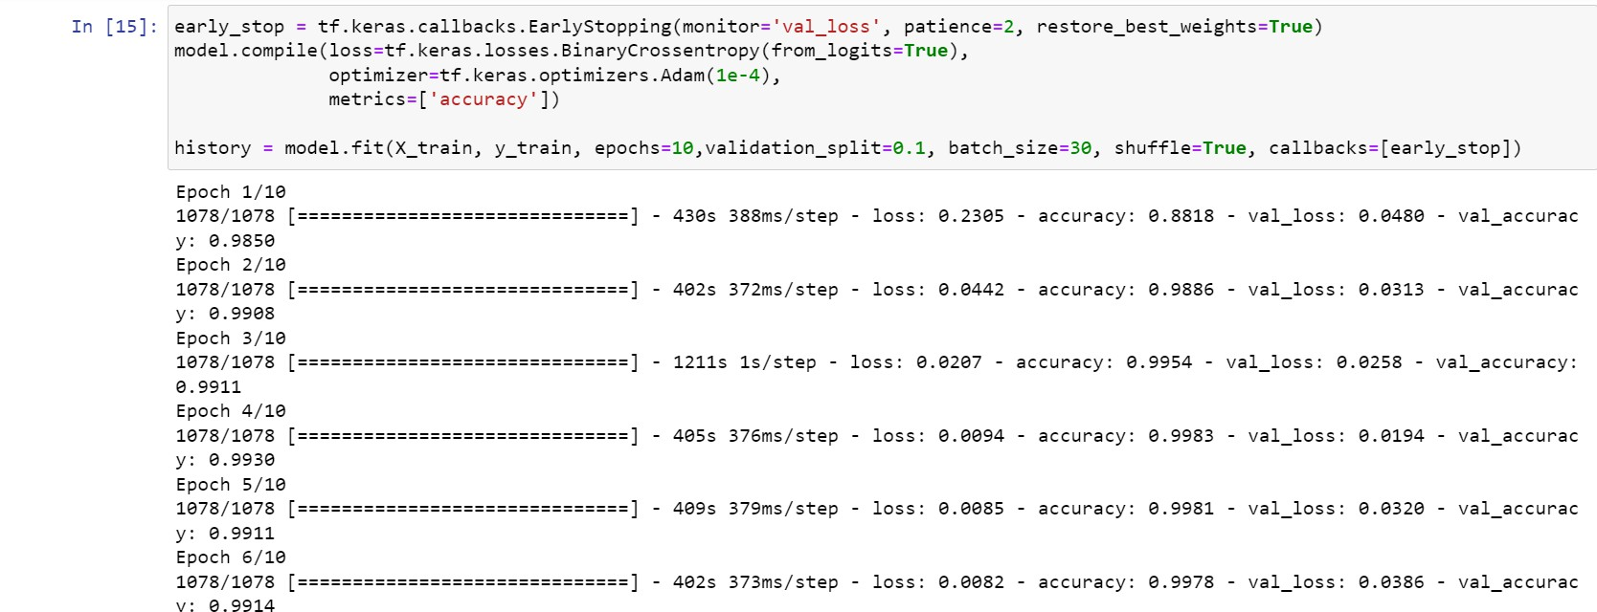

Evaluation Metrics:

Metrics used : define evaluation metrics such as accuracy

, recall , F1- score explain the choice of metrics and how project goals.

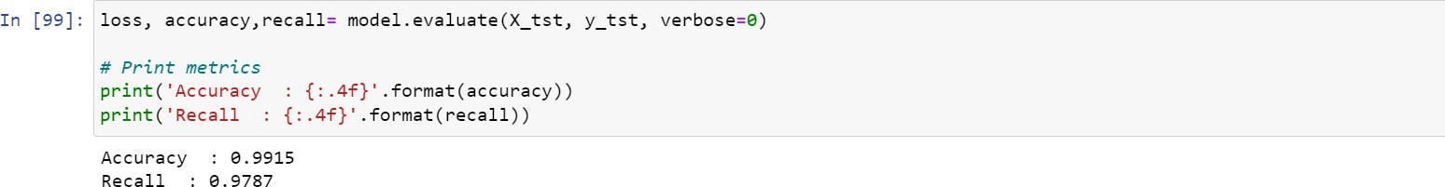

# Project Documentation and reporting:

Separate from the report, create documentation for your Fake news detection, including instructions for usage, system architecture, and any code-related documentation.

Remember to use clear and concise python language in your documentation and reporting.

# Final outcome:

We showed our final outcome for this project:

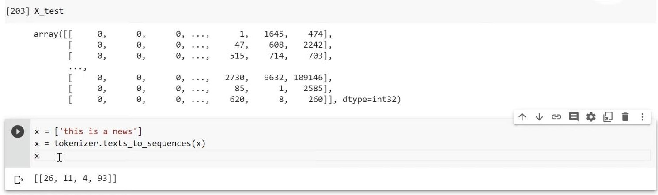

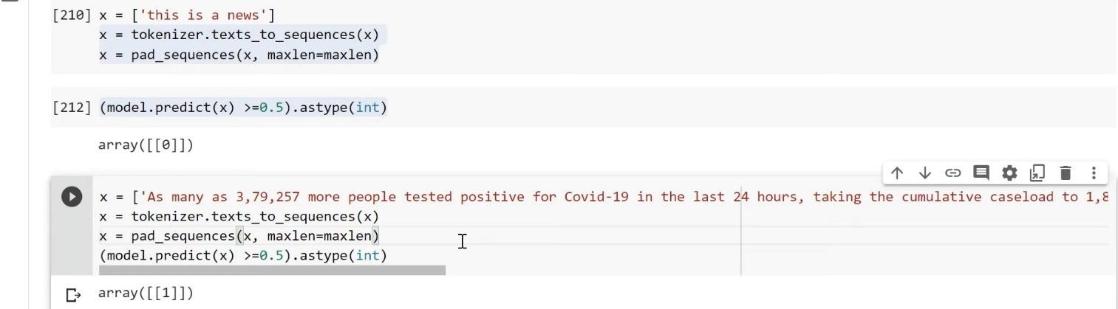

FAKE NEWS :-



**THANK YOU!**